**Assignment No 1 :**

1. **Create database Hospital and list all databases.**

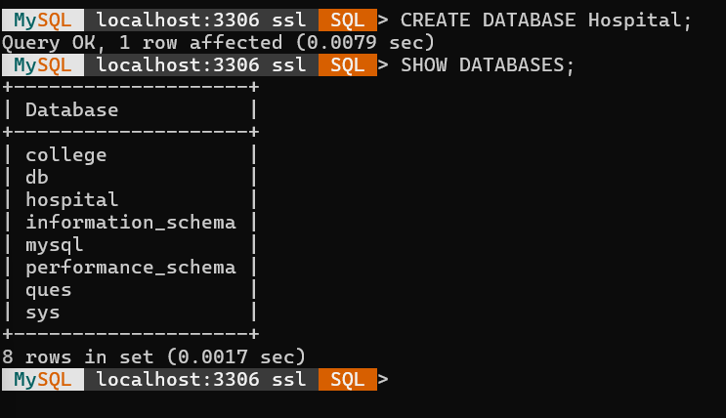

1. **Create both tables and list all existing tables.**

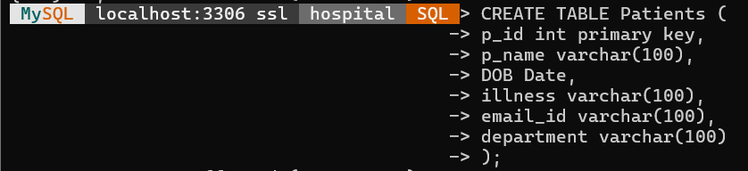

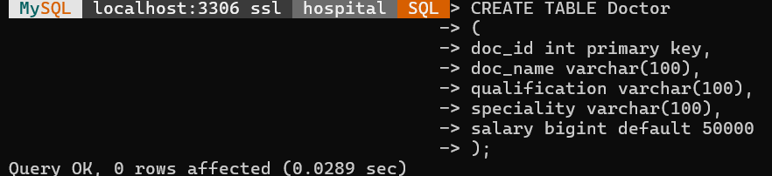

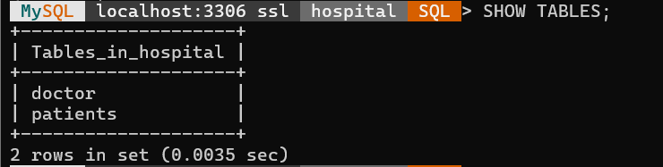

1. **Display the structure of any table.**

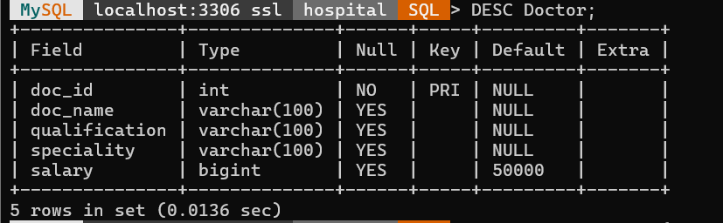

1. **Add atleast 8 records in each table**

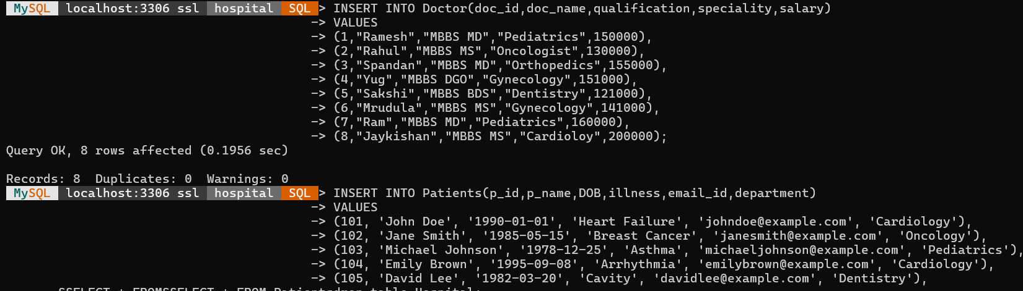

1. **Display all records of Patient Table.**

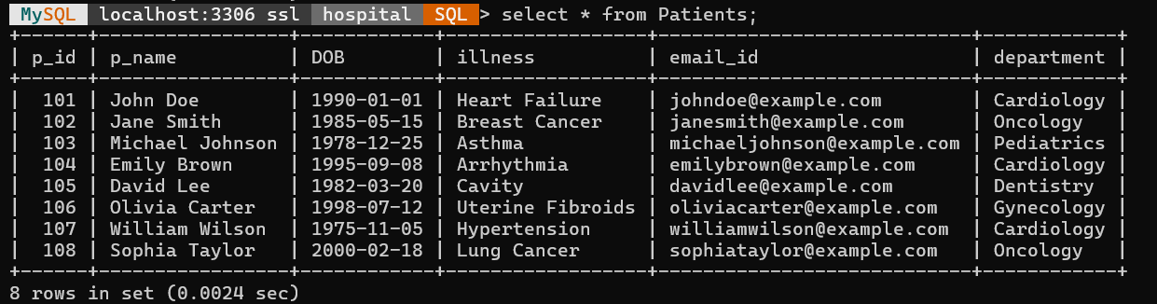

1. **Display all Doctor details who are specialized in Cardiology.**

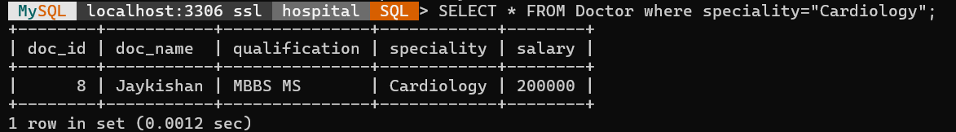

1. **Remove Patient’s record whose id is 102.**

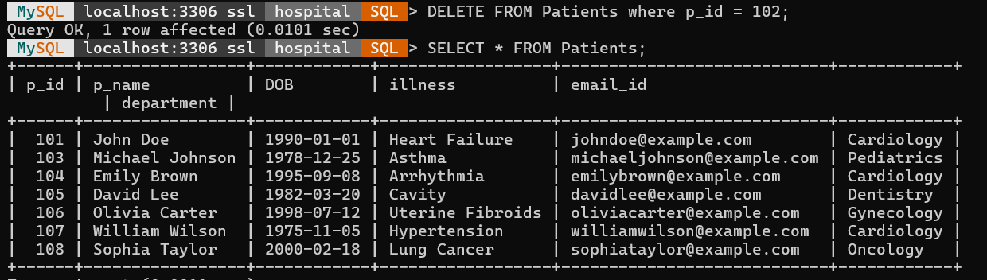

1. **Raise Salary of all doctors by 10000.**

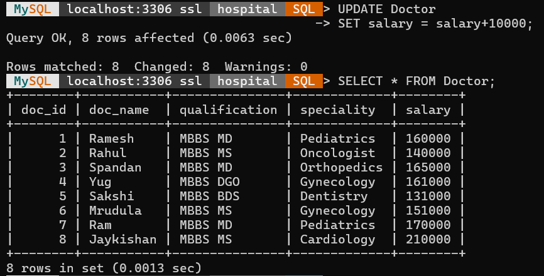

1. **Add Address field to Doctor’s table.**

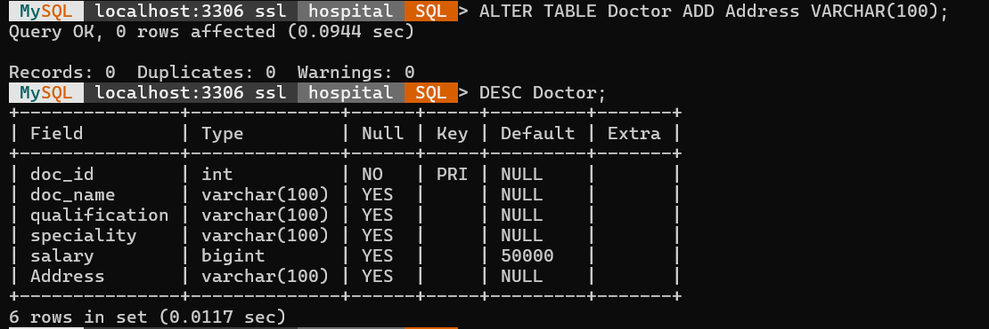

1. **Make entry of address of each doctor**

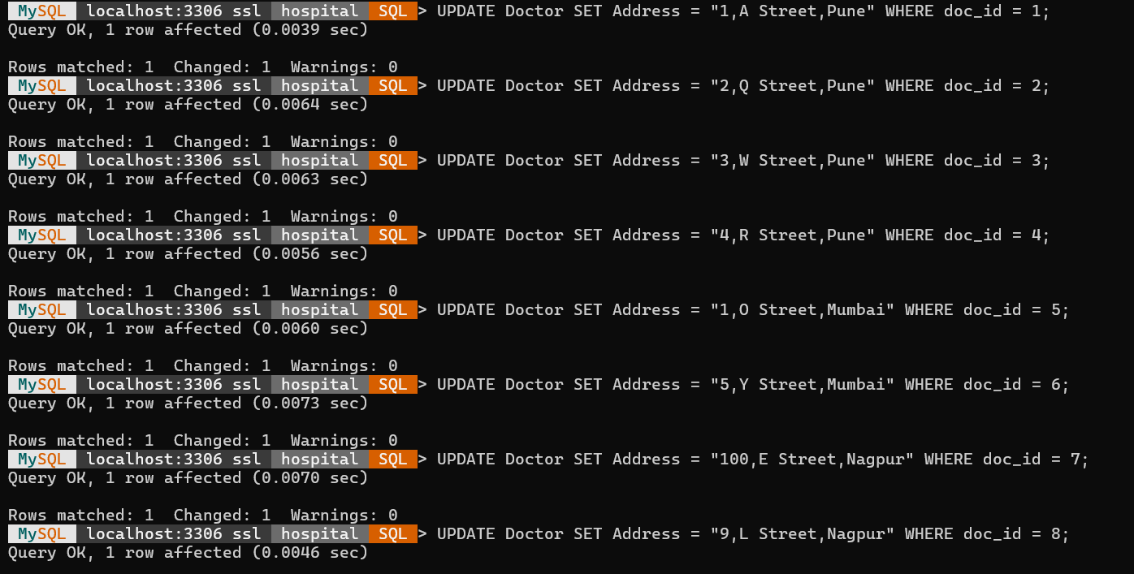

1. **Remove Department field from Patients table.**

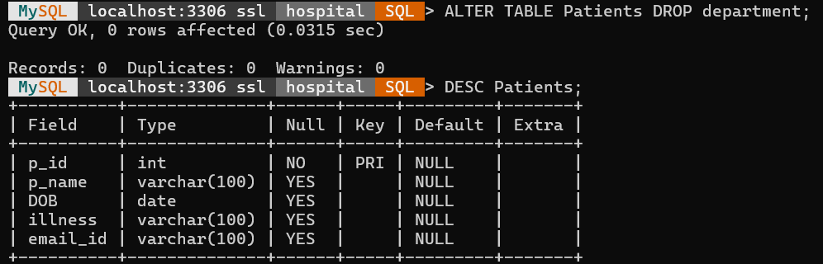

1. **Rename illness fieldname to disease.**

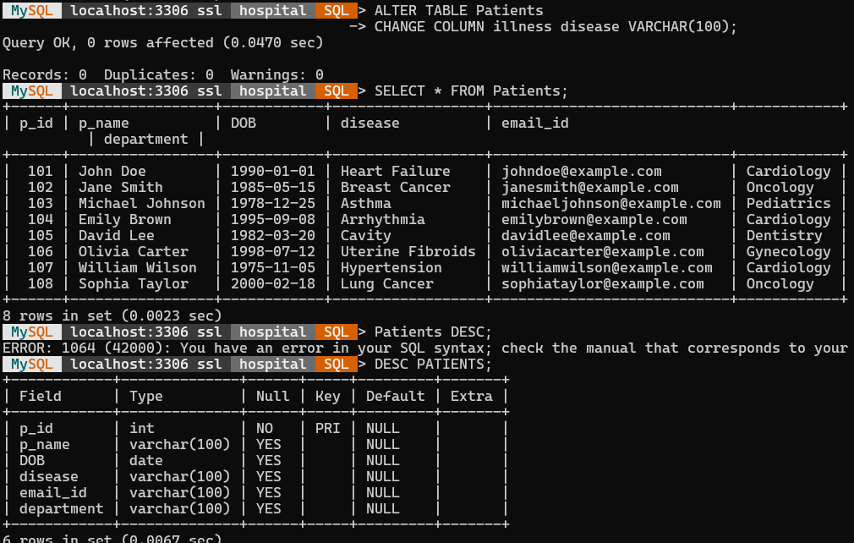

1. **Display doctor details in Descending order. Of their salary.**

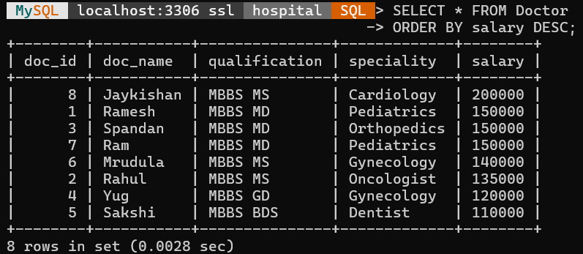

1. **Remove all records of doctor table.**

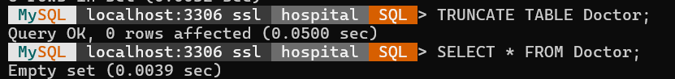

1. **Remove Patients table.**

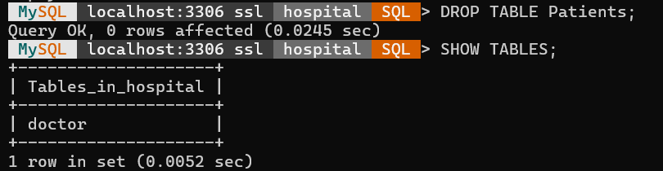

1. **Display patients without email ids.**

